DG INTERNS HUB

AI/ML INTERSHIP

AI/ML Internship – Week 1 Task

Topic: Python Fundamentals for AI

STUDENT NANE: NEHA FULE. EMAIL:neha.dgintershub@gmail.com.

Date of submission: 7 october2026

Task 1: Student Management System
Code:
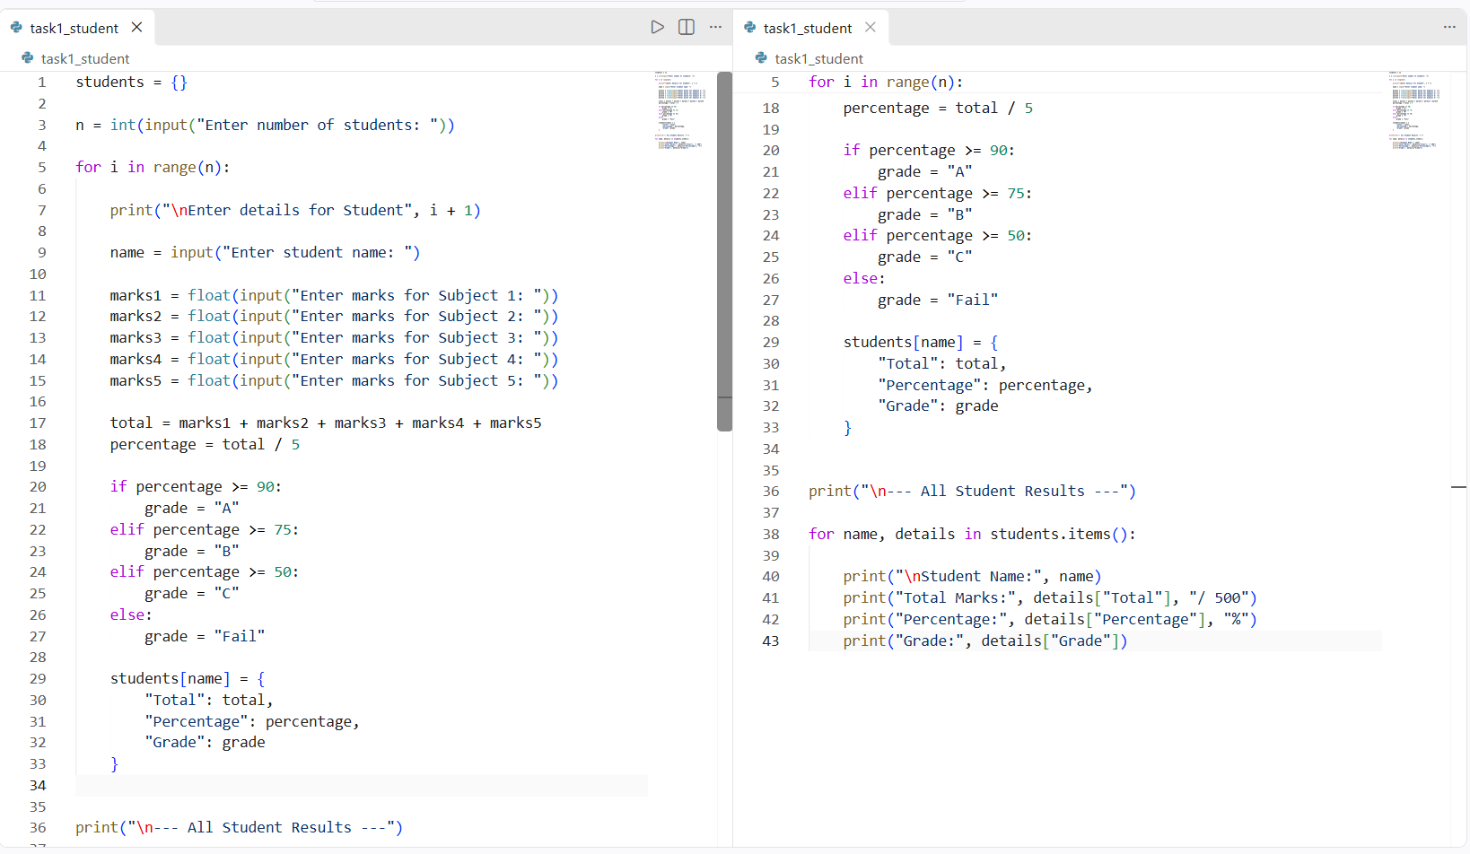

Output:
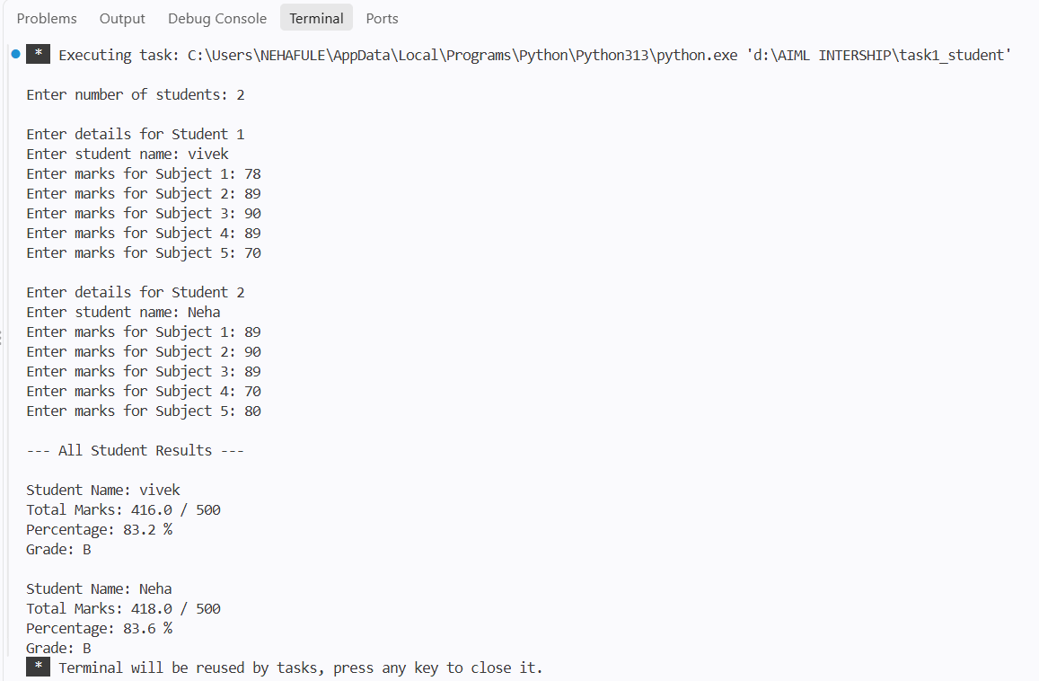
Explanation:
This program takes the student's name and marks as input, calculates total marks and percentage, and displays the grade according to the percentage.
Task 2: Smart Calculator
Code:
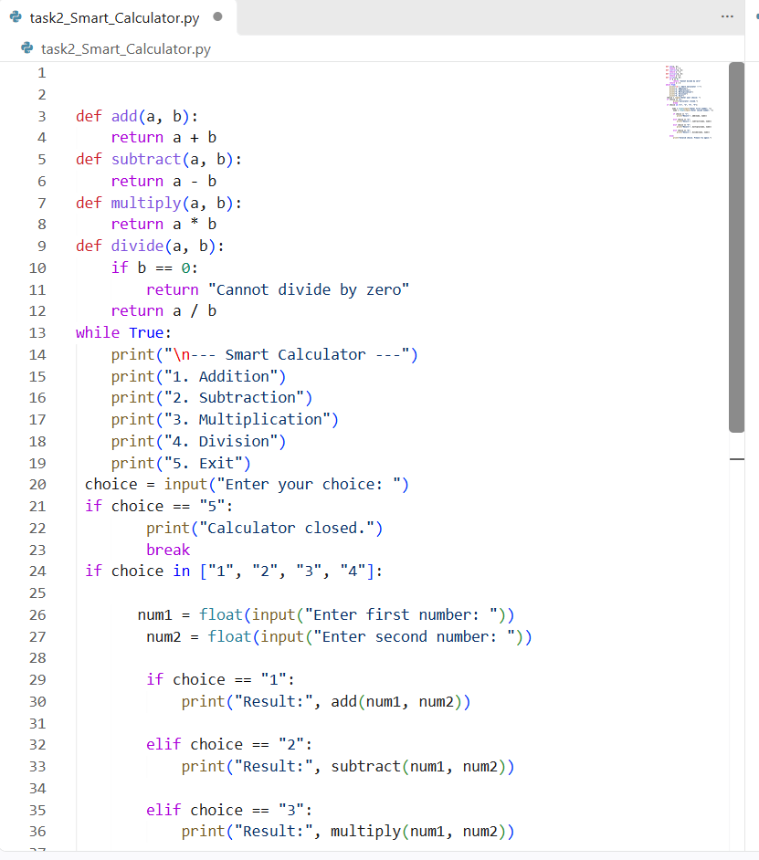
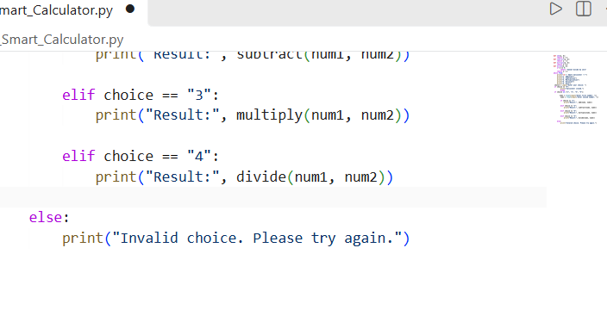
Output:

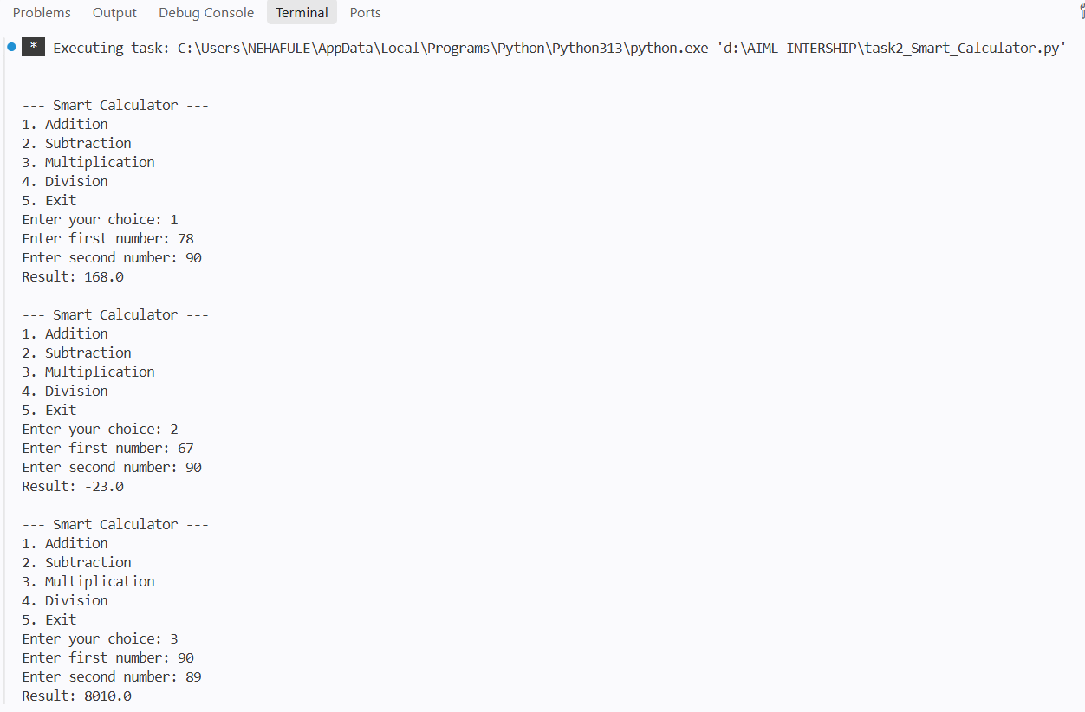
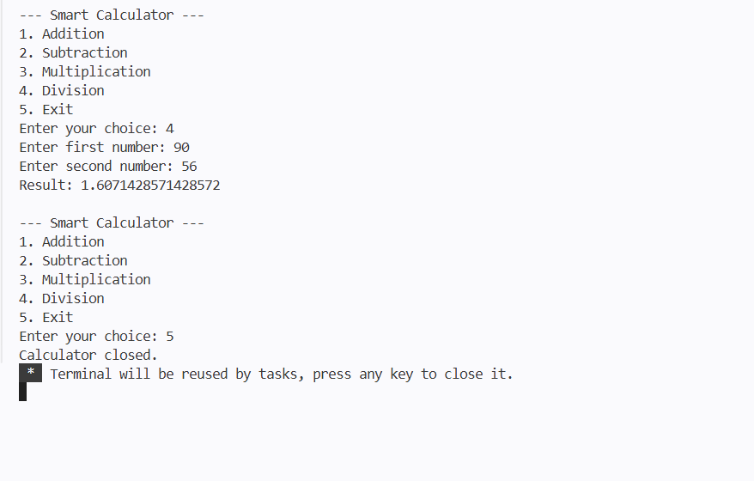
Explanation:
This program performs addition, subtraction, multiplication, and division using functions and a loop-based menu system.

Task 3: Fibonacci
Code:
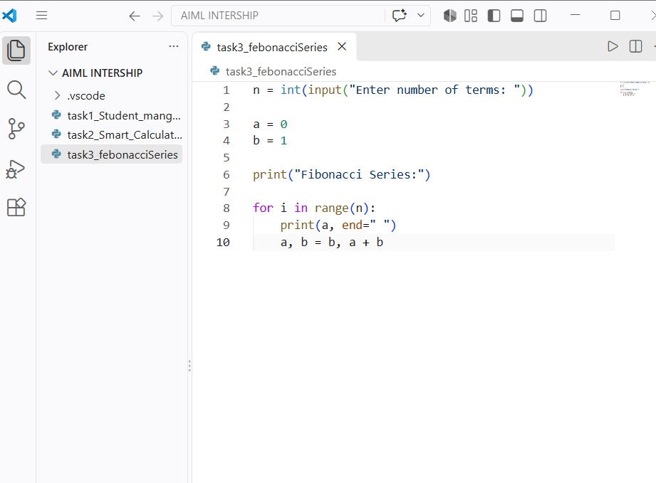
Output:
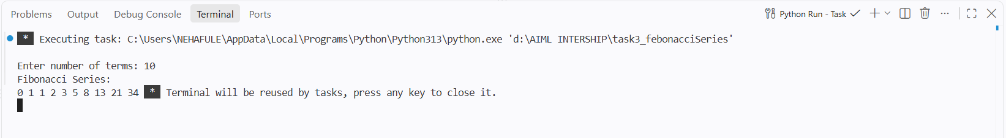
Explanation:
This program generates the Fibonacci series for the number of terms entered by the user using a for loop

Task 3 – Prime Number
Code:
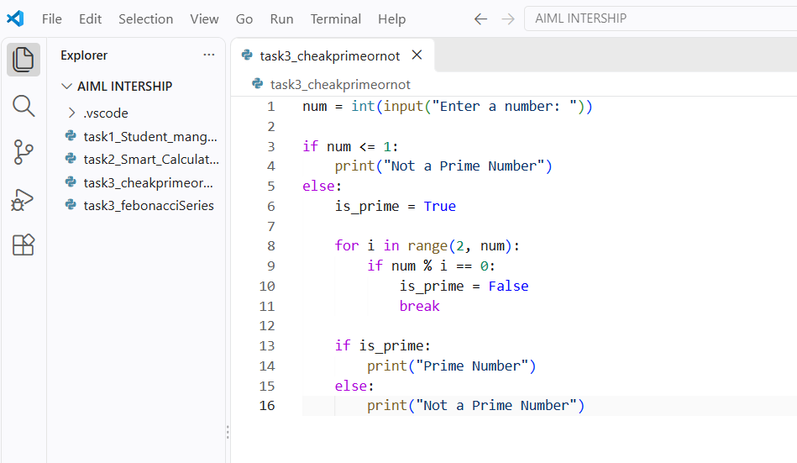
Output:
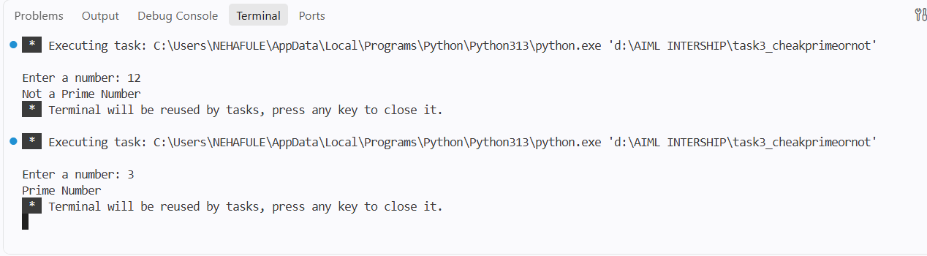
Explanation:
This program checks whether the given number is prime by testing its divisibility using a for loop.

